Julius Ranoa

CSC 121 001 Computer Science I

Homework – Chapter 8 Arrays

**Part I. Review Questions @ Page 589 – 591.**

Qn. 1, 3, 4, 6, 9, 10, 12 – 14, 21, 23, 24, 27.

1. The *size declarator* indicates the number of elements, or values, an array can hold.

3. Each element of an array is accessed is accessed and indexed by a number known as a(n) *subscript*.

4. Subscript numbers in C++ always start at *0*.

6. C++ has no array *bounds* checking, which means you can inadvertently store data past the end of an array.

9. If the size declarator of an array definition is omitted, C++ counts the number of items in the *initialization list* to determine how large the array should be.

10. Look at the following array definition:

double amount[5];

A. How many elements does this array hold? *5*

B. What can you store in amount[5]? *Five double values.*

12. You cannot use the *assignment* operator to copy data from one array to another in a single statement.

13. Arrays are never passed to functions by *value* because there would be too much overhead in copying all the elements.

14. To pass an array to a function, pass the *name* of the array.

21. Look at the following array definition.

int values[10];

A. How many elements does this array have? *10*

B. What is the subscript of the first element of the array? *0*

C. What is the subscript of the last element of the array? *9*

D. If an int uses four bytes of memory, how much memory does the array use? *40 bytes.*

23. Look at the following array definition.

int numbers[5] = { 1, 2, 3 };

A. What value is stored in numbers[2]? *3.*

B. What value is stored in numbers[4]? *0 if it’s a global declaration, garbage if local.*

24. Assume that array1 and array2 are both 25-element integer arrays. Indicate whether each of the following statements is legal or illegal.

A. array1 = array2; *Illegal.*

B. cout << array1; *Legal but prints the address of the first element of the array.*

C. cin >> array2; *Illegal.*

27. Look at the following array definition.

double sales[8][10];

A. How many rows does the array have? *8 rows.*

B. How many columns does the array have? *10 columns.*

C. How many elements does the array have? *80 elements.*

D. Write a statement that stores 3.52 in the last column of the last row in the array. *sales[7][9] = 3.52;*

**Part II. Programming Challenge @ Page 595 - 596.**

Qn. 10 – Baseball Champions.

Screenshot of Runtime:

(1) *Detroit Tigers* (2) *Anaheim Angels* (3) *New York Yankees*

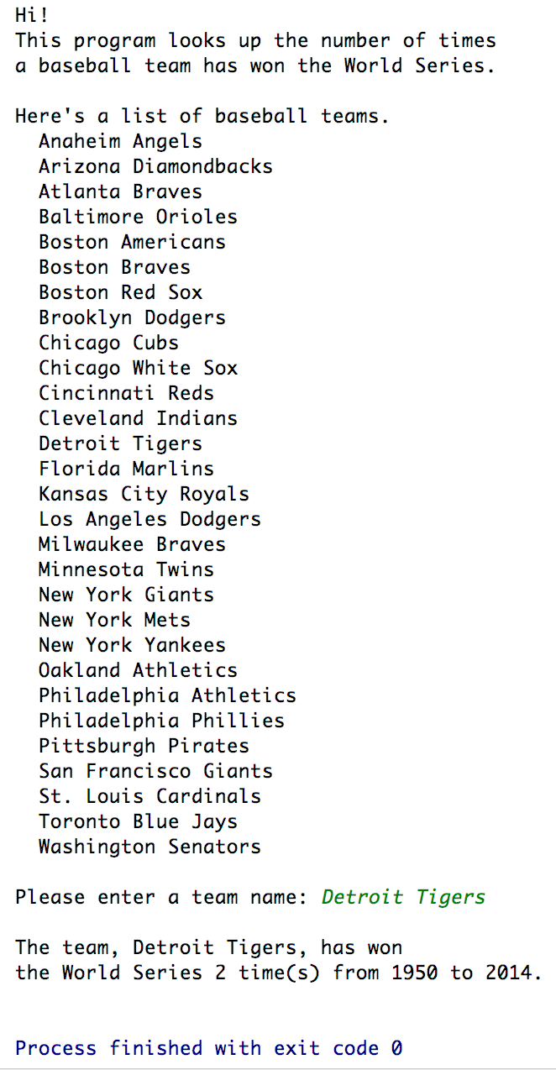 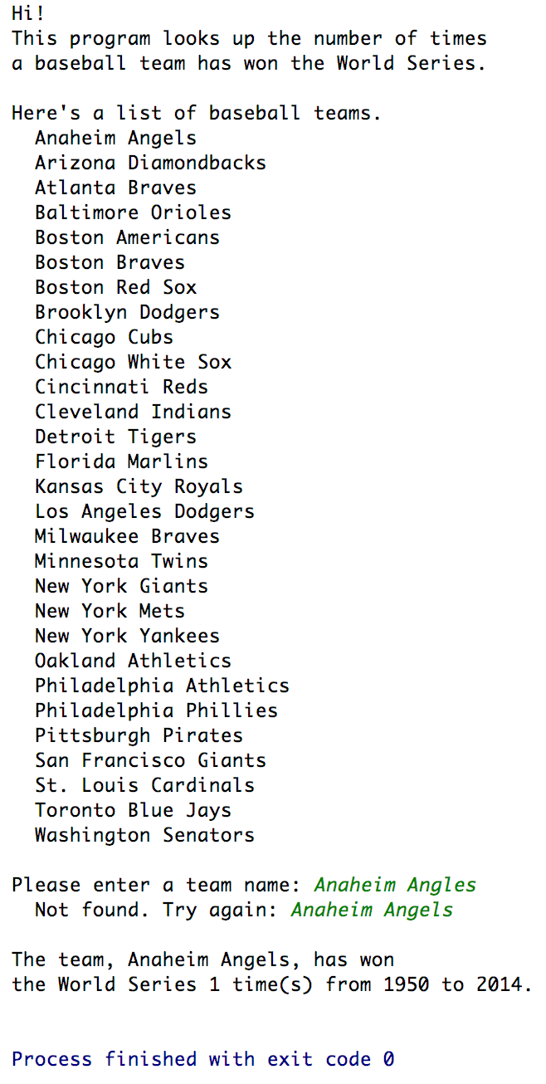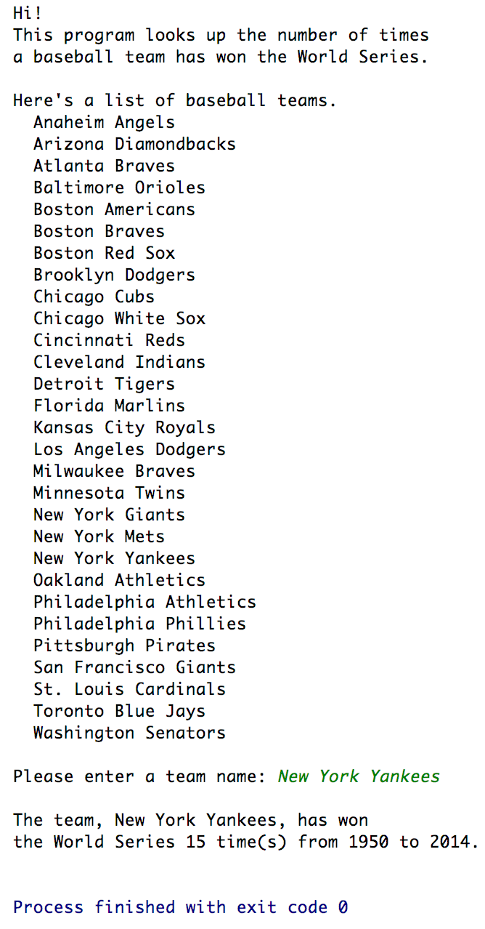

Source Code:

1. *BaseballChampions.h*
2. *BaseballChampions.cpp*
3. *main.cpp*

The source code is also stored at Github.

Link below:

<https://github.com/TheLoneWoof1102/FA17_CSC121001/tree/master/Source%20Code/Homework-Ch8.Qn10>

**main.cpp**



**// END of *main.cpp*.**

**BaseballChampions.h**



**// END of *BaseballChampions.h*.**

**BaseballChampions.cpp**



**// *BaseballChampions.cpp* is continued next page.**

**BaseballChampions.cpp – cont’d.**



**// END OF *BaseballChampions.cpp*.**